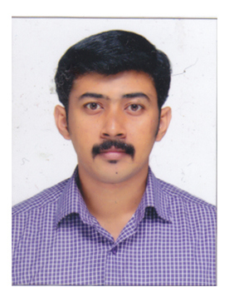

MATHEW TONY THERATTIL
THERATTIL HOUSE
NEW GARLAND ROAD
ELTHURUTH- PO, LALOOR
THRISSUR, KERALA Mobile: +919961045859
PIN- 680611 mathewtonytheratill@gmail.com
WORK EXPERIENCES
- Worked as SALES EXECUTIVE in ARCHANA MOTORS the dealer of BAJAJ MOTOR BIKES, Thrissur for a period of 8 months
- Worked as SALES EXECUTIVE IN PLATINO CLASSIC the dealer of BMW CARS, KOCHI for a period of 4 months
EDUCATIONAL QUALIFICATIONS:
TIME OF COURSE | NAME OF COURSE | INSTITUTION/ BOARD/UNIVERSITY
2012-2014 | MBA (Marketing with Finance) COUSE COMPLETED | HOLY GRACE ACADEMY OF MANAGEMENT STUDIES, MALA  UNIVERSITY OF CALICUT
2008-2011 | DEGREE, B.COM computer application (Completed ) | DON BOSCO COLLEGE, MANNUTHY, THRISSUR  UNIVERSITY OF CALICUT
2006-2008 | HIGHER SECONDARY  (Class XII) | ST. THOMAS COLLEGE THRISSUR
2006 | SSLC | N.S.S.E.M.H.S AYYANTHOL
ADDITIONAL QUALIFICATIONS:
I am elected as college union chairman for one year (2009-10)
I lead HR team in the management fest that conducted by college( MBA) (2012-2014)

Computer Skills: MS OFFICE, INTERNET

Language: Malayalam, English

PERSONAL INFORMATION
Father’s Name : TONY MATHEW
Date of Birth : 30/09/1989
Marital status : Single
Gender : Male
Religion : Christian
STRENGTH
Hard working, self-confident, positive attitude

HOBBIES
Reading and collecting automotive magazines, playing badminton, social networking

DECLARATION
I hereby declare that all the above-furnished statements are true and correct to the best of my knowledge and belief.

Date:
Place: THRISSUR
MATHEW TONY THERATTIL

